South China University of Technology
《Computer Organization and Architecture》Experiment Report
Experiment Title： Bus & Register
Name： 林宇晟 Student ID： 202130430140
Class： 21计创 Group：
Collaborator：
Teacher： 毛爱华
Description
【Objective and Requirement】
Objective：
Section 1: Bus & Buffer Experiment:
Draw the bus and set the dial switcher, achieve the goal of passing the data from switcher to bus.
Section 2: Register Experiment:
Using 74LS374 achieve the common register R0, using 74LS273 and 74LS244 to achieve the function of data latch, and comparing the difference between them.
Section 3: Shift Register Experiment:
Using 74LS194 to achieve the function of shift register, including the operation of translation between parallel and serial and the opearation of logic shifting and mathematic shifting.

Requirement：
None.
【Environment】
Operating System：Windows 11
Content
【Procedure】
- Step：
Section 1
Place the needed components into the diagram.
Use BUS to connect them.
Set the data 0x55 (0101 0101) on the 8-bit switcher connecting to the bus, and check the results in 7SEG-BCD(LED light).
Section 2
Set the data 0xAA (1010 1010) on the 8-bit switcher connecting to the bus DIN and compare the difference between the bus DIN and bus BUS.
Register R0(74LS374)
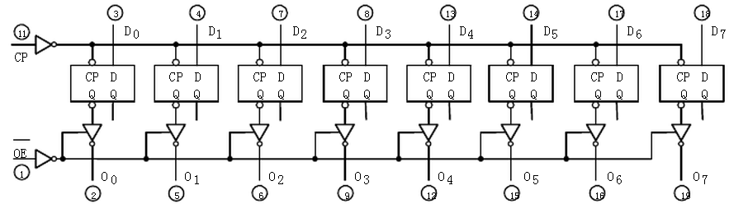
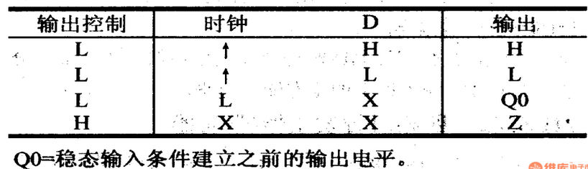
Write the data 0xAA (1010 1010) onto the register R0 by triggering the CLK, block the output of the R0, and observe the status of the bus BUS(Using Led light or prober).
Block the 74LS244 and see what happen to the bus BUS.
DR(74LS273)
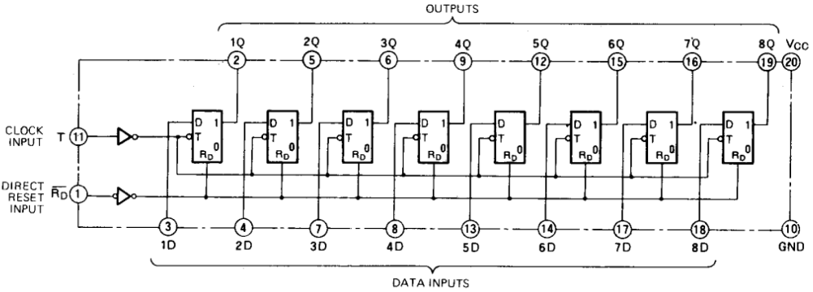
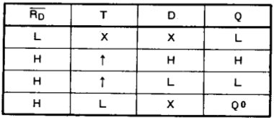
Repeat the above operations with replacing 74LS273 to 74LS374, then compare the differences of result.
Section 3
SR, set the data 5H (00000101)serial setting on the register U1.
SL, set the data AH (00001010)serial setting on the register U2.
SL, set the data 0x55 (0101 0101)serial setting on the 8-bit register .
SR, set the data 0xAA (1010 1010) serial setting on the 8-bit register .
Switch on the register R0, output the data to the shift register U1. Set the SR to 0, trigger the CLK signal to make a double operation.
Switch on the register DR, output the data to the shift register U2. Set the SL to 0, trigger the CLK signal to make a half division operation.

2. Data：

3. Major Procedure：
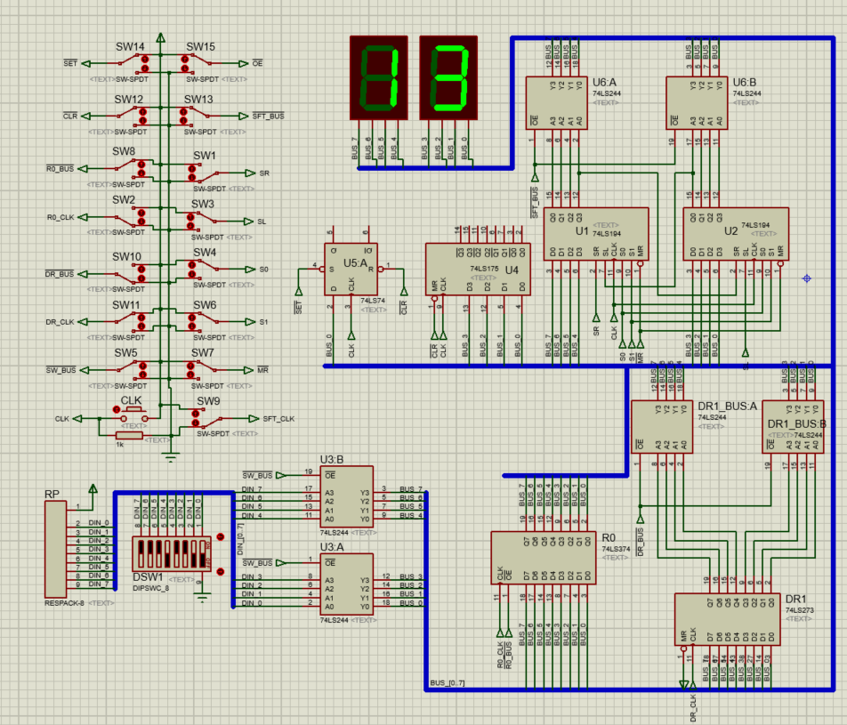
Conclusion
Teacher’s Comments and Score
Comment：

Score： Signature：
Date：

